Smart Lender – Loan Eligibility Prediction System
3. Building HTML Pages
3.1 Introduction
The frontend of the Smart Lender application is developed using HTML. These web pages provide an interactive interface where users can enter their loan application details and view the prediction result. The HTML pages are connected to the Flask backend, allowing seamless communication between the user interface and the machine learning model.
3.2 Objective
The objective of this task is to design and develop user-friendly HTML pages for the Smart Lender application. These pages collect the applicant's information, send it to the backend for processing, and display the loan prediction result.
3.3 HTML Pages Used
The application consists of the following HTML pages:
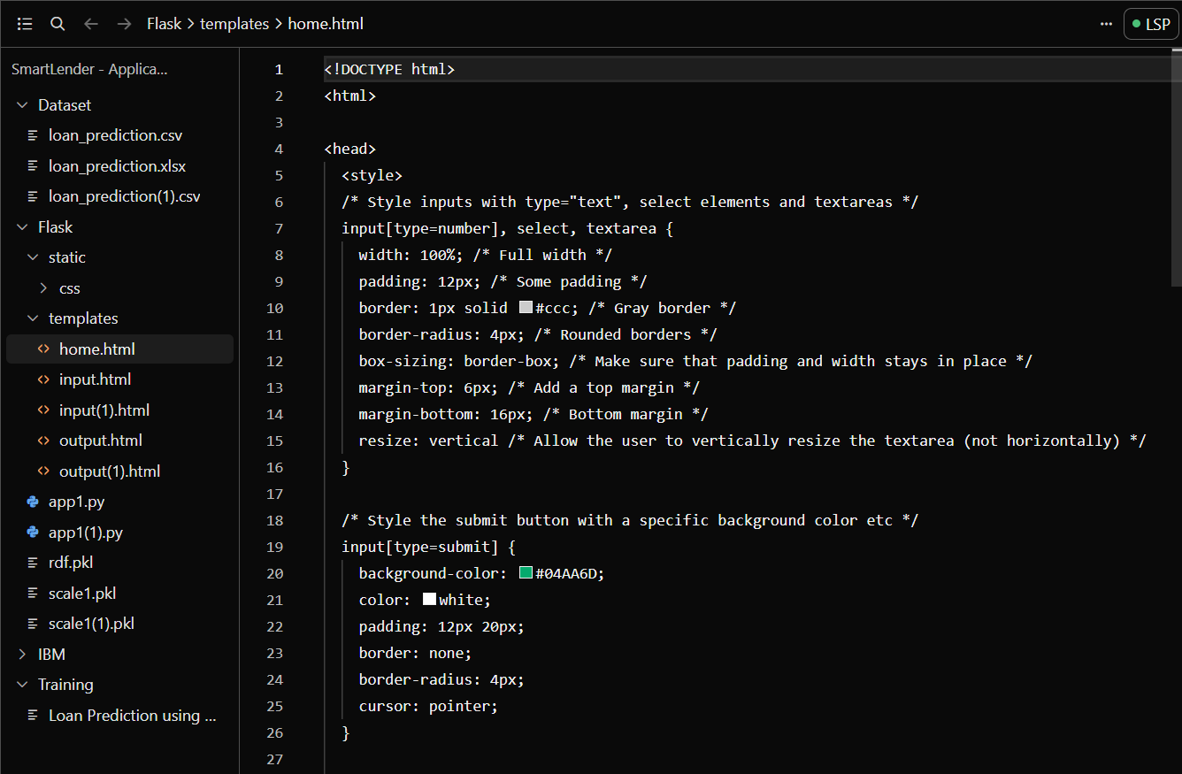
- Home Page (home.html) – Displays the project title and provides navigation to the loan prediction page.

- Prediction Page (predict.html) – Contains a form where users enter details such as gender, education, income, loan amount, and credit history.
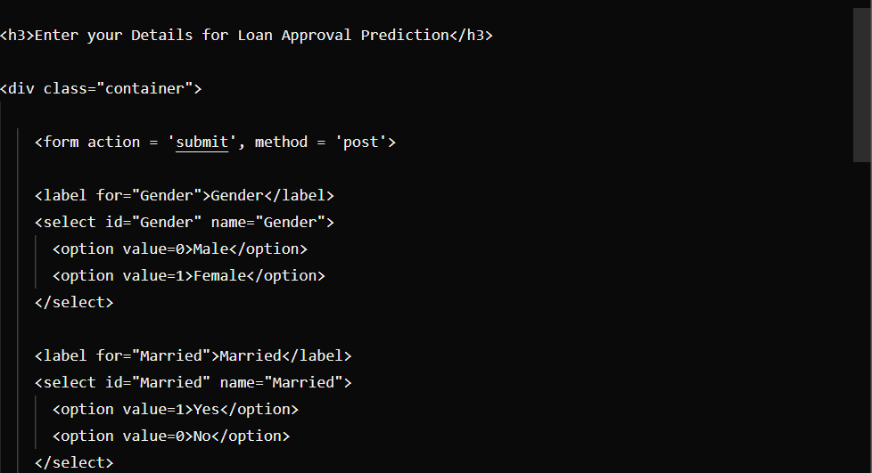
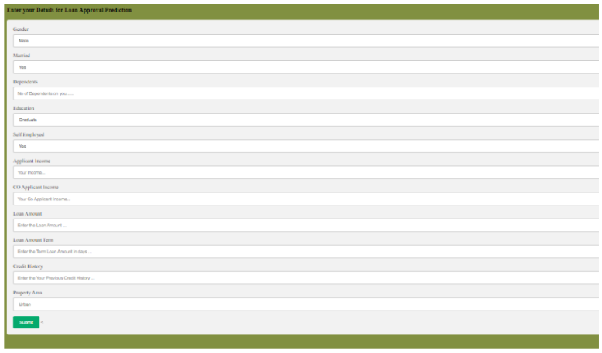
- Result Page (submit.html / output.html) – Displays the final prediction generated by the machine learning model, indicating whether the loan is approved or rejected.

3.4 Implementation
The HTML pages were created using standard HTML elements such as forms, input fields, labels, buttons, and tables. Each input field corresponds to an attribute required by the machine learning model. The form data is submitted to the Flask application, which processes the information and returns the prediction result. The pages were designed to provide a simple and user-friendly experience.
3.5 Application Flow
The interaction between the HTML pages and the backend follows this sequence:
Home Page → Prediction Form → Flask Backend → Machine Learning Model → Result Page

